**MYSQL PROJECT**

**LOAN MANAGEMENT SYSTEM**

**NAME :- MST SURAJ JAIPRAKASH GUPTA**

**COURSE :- DATA SCIENCE AND DATA ANALYTICS WITH ARTIFICIAL INTELLIGENCE**

**DATASET :-**

**THIS SOURCE OF THIS DATASET IS BEING RETRIEVED FROM GITHUB**

BANK DEALS WITH MANY CUSTOMER THROUGH OUT THEIR BRANCHES BY PROVIDING THEM WITH LOAN FACILITIES,CARDS,HELP THEM TO DO TRANSACTION WITH THE CARDS BEING ASSIGNED TO THEM. THIS PROJECT AIMS TO CREATE AND MANAGE A RELATIONAL DATABASE MANAGEMENT SYSTEM WHICH HELPS THE BANK TO FIGURE OUT WITH THE CUSTOMER’S INFORMATION.

**AVAILABLE TABLES :-**

* **BRANCH**
* **CARD**
* **LOAN\_TYPE**
* **CUSTOMERS**
* **ACCOUNTS**
* **LOANS**
* **TRANSACTIONS**

**ENTITY RELATIONSHIP DIGRAM :-**

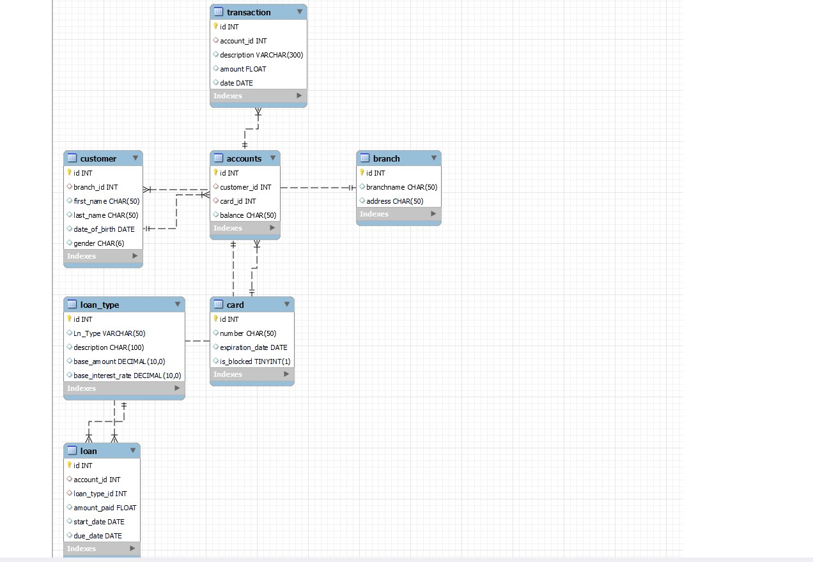

**CREATING DATABASE AND TABLES :-**

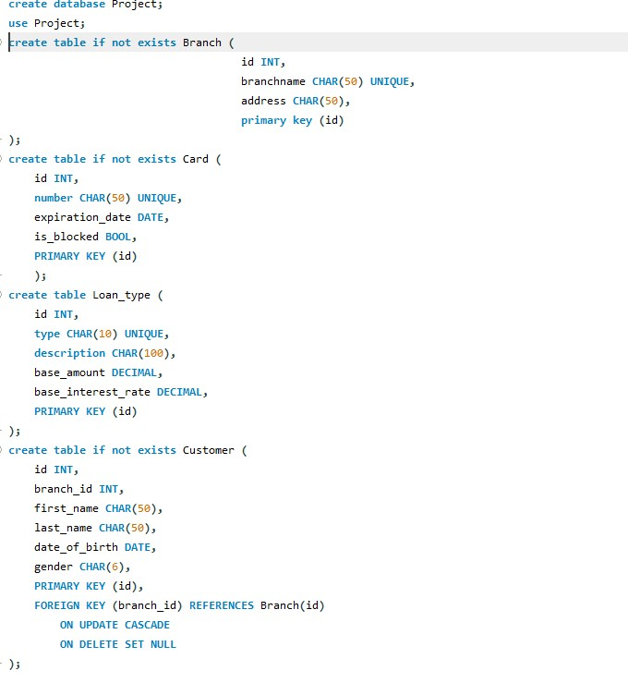

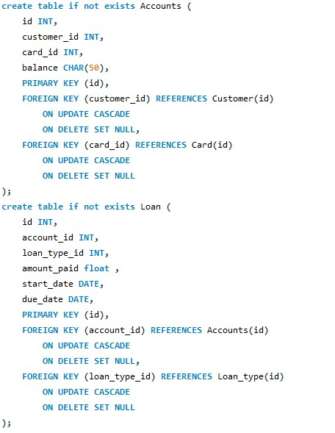

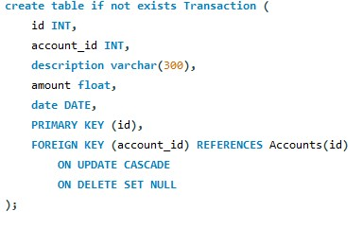

**INSERTING VALUES IN TO THE TABLES :-**

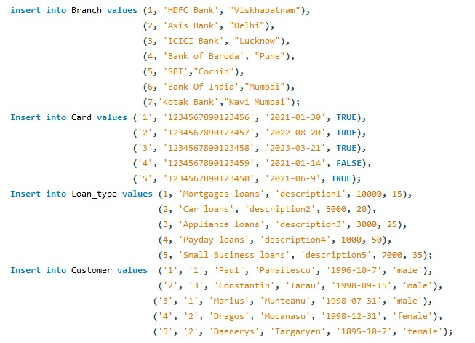

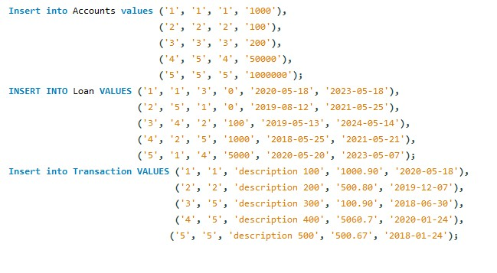

**DISPLAYING STRUCTURE AND DATA OF EACH TABLE :-**

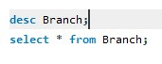

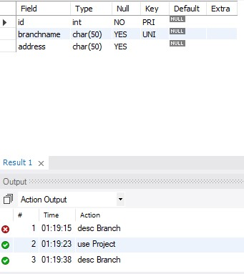

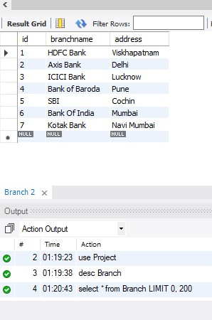

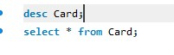

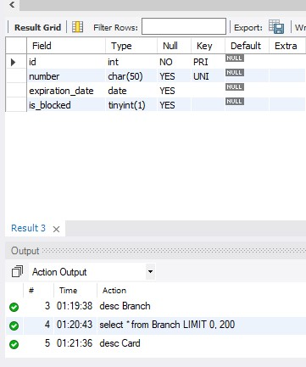

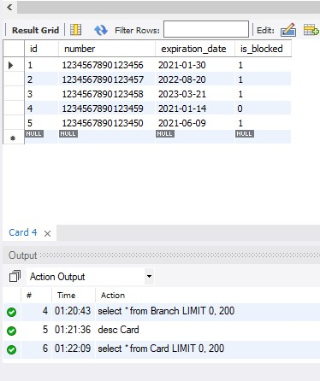

C:\Users\Admin\AppData\Local\Packages\Microsoft.Windows.Photos_8wekyb3d8bbwe\TempState\ShareServiceTempFolder\4.jpeg

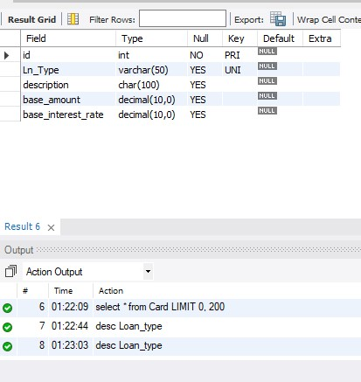

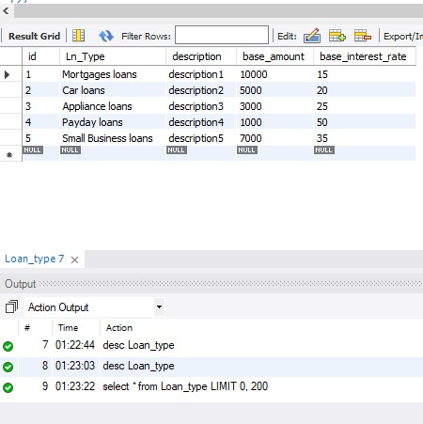

C:\Users\Admin\AppData\Local\Packages\Microsoft.Windows.Photos_8wekyb3d8bbwe\TempState\ShareServiceTempFolder\7.jpeg

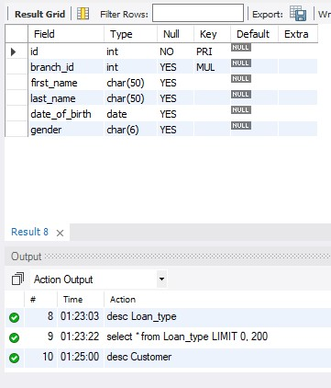

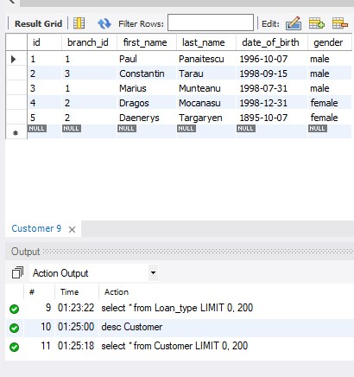

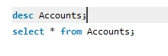

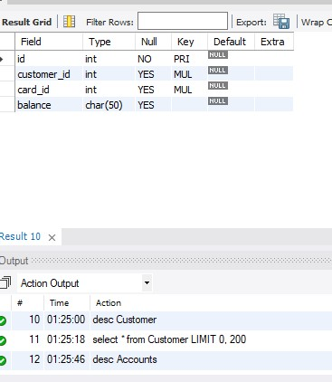

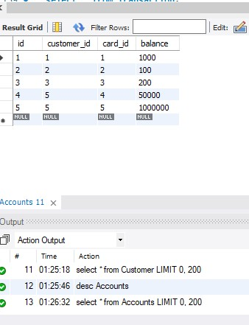

C:\Users\Admin\AppData\Local\Packages\Microsoft.Windows.Photos_8wekyb3d8bbwe\TempState\ShareServiceTempFolder\13.jpeg

